***3 Interpreting Neural Networks [40 pts]***

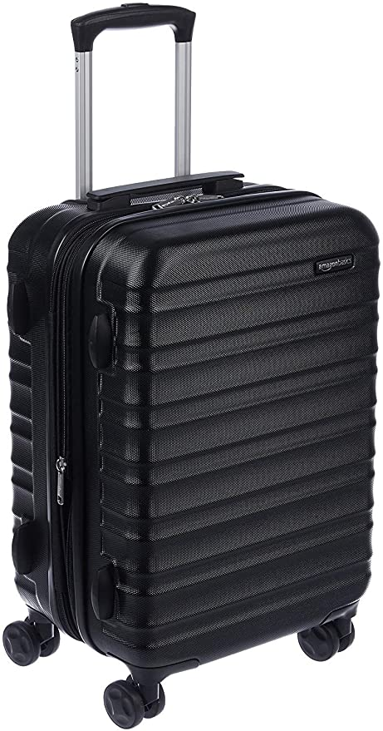

1. **Top five predictions and probs**

**('n04265275', 'space_heater', 0.62474257)**

**('n04041544', 'radio', 0.042016856)**

**('n04040759', 'radiator', 0.041702427)**

**('n04442312', 'toaster', 0.019159246)**

**('n04111531', 'rotisserie', 0.016038848)**

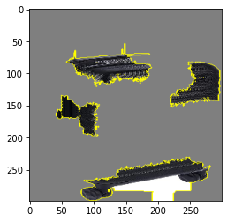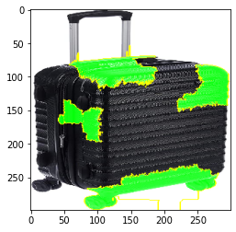

*According to the boundaries area the classification is not well defined.*

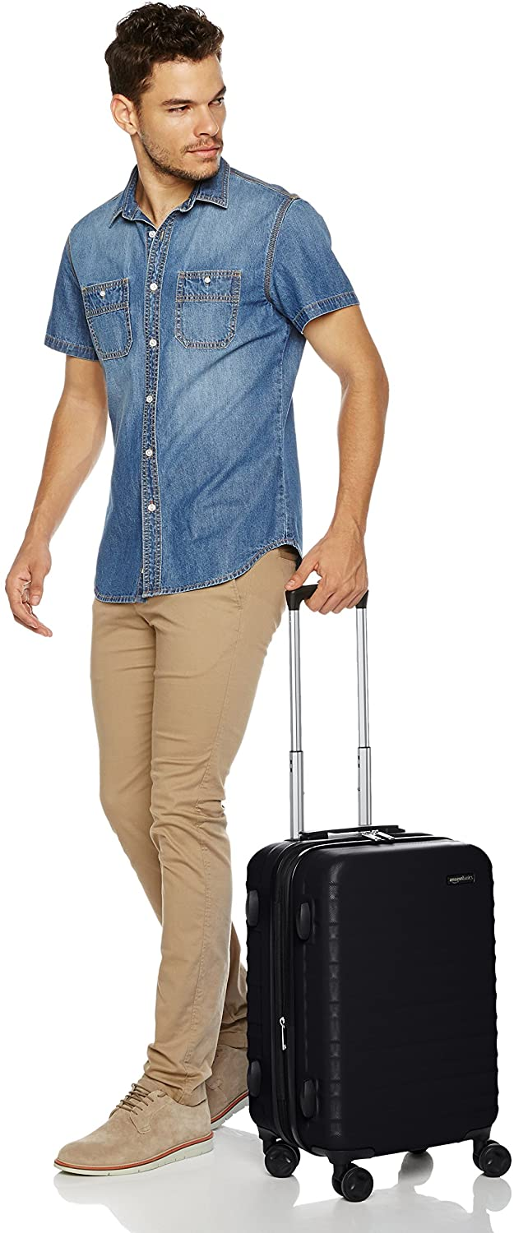

1. **Top five predictions and probs**

**('n03594734', 'jean', 0.12457314)**

**('n02963159', 'cardigan', 0.090886645)**

**('n04517823', 'vacuum', 0.07377569)**

**('n02769748', 'backpack', 0.031545497)**

**('n03980874', 'poncho', 0.011480665)**

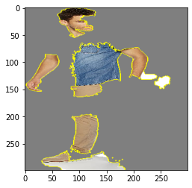

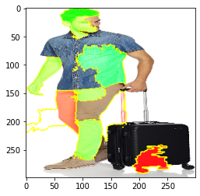

*According to the boundaries area the classification is well defined.*

1. **Top 5 predictions and probs**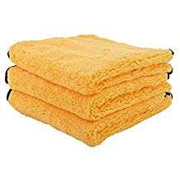

**('n02808304', 'bath_towel', 0.9750167)**

**('n04344873', 'studio_couch', 0.0030538419)**

**('n03223299', 'doormat', 0.0014694714)**

**('n04599235', 'wool', 0.0011654152)**

**('n04209239', 'shower_curtain', 0.0011083777)**

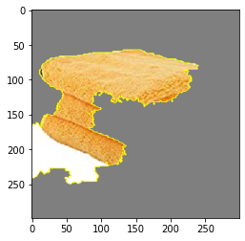

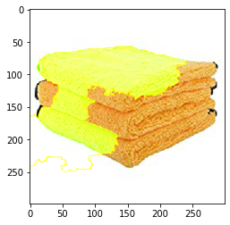

*According to the boundaries area the classification is well defined.*

1. **Top five predictions and probs**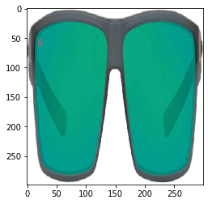

**('n04355933', 'sunglass', 0.86909425)**

**('n04356056', 'sunglasses', 0.12334232)**

**('n04357314', 'sunscreen', 0.0001756017)**

**('n03680355', 'Loafer', 0.00012325066)**

**('n03793489', 'mouse', 9.077392e-05)**

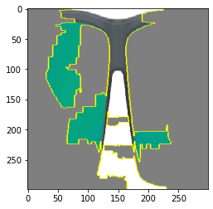

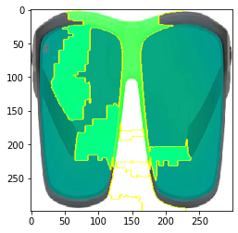

*According to the boundaries area the classification is well defined.*

**5. Top five predictions and probs**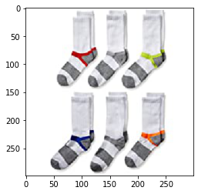

**('n03197337', 'digital_watch', 0.51810086)**

**('n04579432', 'whistle', 0.1383834)**

**('n02966687', "carpenter's_kit", 0.036015928)**

**('n04372370', 'switch', 0.026099157)**

**('n04019541', 'puck', 0.02062653)**

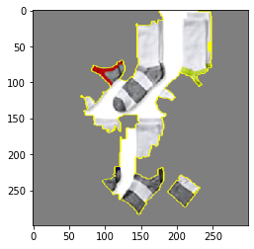

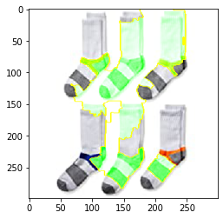

*According to the boundaries area the classification is not well defined.*

**6. Top five predictions and probs**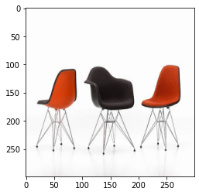

**('n04099969', 'rocking_chair', 0.76237077)**

**('n03376595', 'folding_chair', 0.073354386)**

**('n03201208', 'dining_table', 0.0040207515)**

**('n04344873', 'studio_couch', 0.0030291225)**

**('n03047690', 'clog', 0.0029680138)**

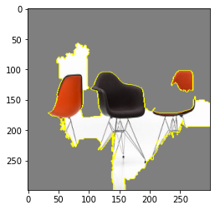

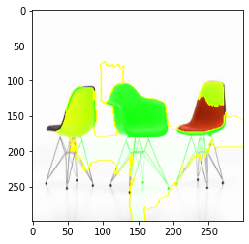

*According to the boundaries area the classification is well defined.*

**7. Top five predictions and prob**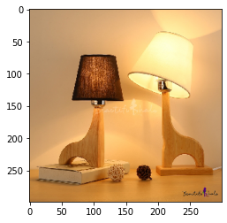

**('n04380533', 'table_lamp', 0.81699556)**

**('n03637318', 'lampshade', 0.15963711)**

**('n04286575', 'spotlight', 0.00041560034)**

**('n02870880', 'bookcase', 0.00021121703)**

**('n03196217', 'digital_clock', 0.00016094094)**

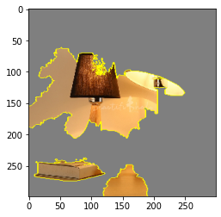

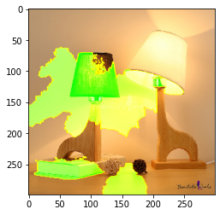

*According to the boundaries area the classification is well defined.*

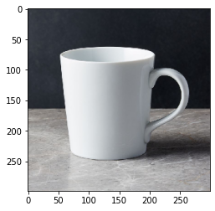

***8.* Top five predictions and prob**

**('n03063599', 'coffee_mug', 0.55225056)**

**('n07930864', 'cup', 0.39505714)**

**('n03950228', 'pitcher', 0.020055579)**

**('n03733805', 'measuring_cup', 0.004896856)**

**('n04560804', 'water_jug', 0.0038265265)**

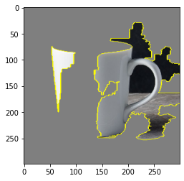

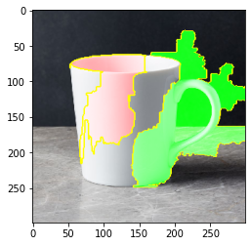

*According to the boundaries area the classification is well defined.*

***9. Top five predictions and probs***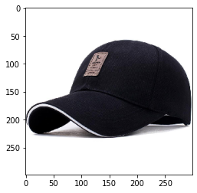

***('n02802426', 'basketball', 0.1819118)***

***('n03127747', 'crash_helmet', 0.08874585)***

***('n09835506', 'ballplayer', 0.041522685)***

***('n02807133', 'bathing_cap', 0.037733246)***

***('n03803284', 'muzzle', 0.026507074)***

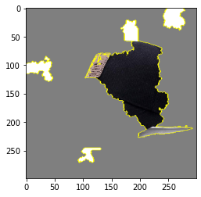

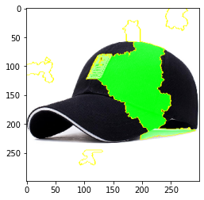

*According to the boundaries area the classification is not well defined.*

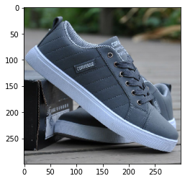

***10. Top five predictions and probs***

***('n04120489', 'running_shoe',0.94716185)***

***('n04133789', 'sandal', 0.0032043813)***

***('n04200800', 'shoe_shop',0.0010591904)***

***('n03047690', 'clog', 0.0010585441)***

***('n04254777', 'sock', 0.00090397295)***

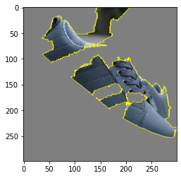

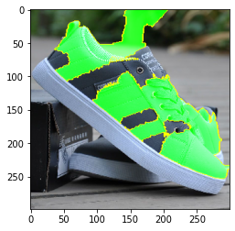

*According to the boundaries area the classification is well defined.*

***3. Based on your observations in Question 1 and 2, is the Inception model interpretable? Are there types of images that seem to fail or succeed? Rationalize your answer with Miller’s definition of “Good Explanations”.***

*Based on the observations in question 1 and 2 for ten observations , we can say that the inception model is pretty much interpretable.*

*There are different images of the different products found on amazon that we checked for the lime model and there we have found that about 1/3rd of the images seem to fail while the other images seem to succeed .For Ex:*

*The image 7 of the lamp is predicted accurately but contradict to that image 5 of socks is not predicted right.*